SFEAM: Secured Face Encryption and Authentication Model for Unique Personal Identification

PSG Institute of Technology and Applied Research, Coimbatore, India

Abstract. This work presents the design and implementation of SFEAM, a system for Aadhaar-based face authentication offering facial recognition as a secure and user-friendly alternative to traditional username and password methods. SFEAM achieves client-side face detection, recognition, and integrated anti-spoofing capabilities within a web browser using face-api.js, built on TensorFlow.js, ensuring efficient operation. Advanced security is provided through multiple layers, including hash verification, AES-256-CBC encryption, and obfuscation. The system demonstrates robust performance across network environments, achieving a perfect score on 5G networks and maintaining acceptable performance on both 4G and 3G networks. Its architecture leverages Azure services for scalable backend operations, featuring Key Vault for encryption key management and geo-replication for high availability. Model size optimization techniques, such as quantization and pruning, successfully keep the model under 7 MB without sacrificing accuracy, enabling efficient use on resource-limited devices. Client-side rendering and computation ensure stringent data privacy by processing all facial recognition tasks locally within the browser, eliminating the transmission of sensitive biometric data. With a face detection and comparison time of under one second, SFEAM offers rapid authentication. This research contributes to the advancement of secure, privacy-preserving biometric authentication systems suitable for widespread adoption in national identity verification frameworks such as MeriPehchaan.
Keywords: Facial authentication, Aadhaar integration, Client-side computing, Anti-spoofing, Caching mechanisms, Biometric, Privacy-preserving authentication.

1. Introduction

Face authentication is rapidly becoming integral to modern digital identity verification, particularly as government services and national identity infrastructures, such as India's Aadhaar, accelerate digitization efforts. Traditional authentication methods such as passwords and PINs are increasingly recognized for their inherent security limitations, user inconvenience, and scalability issues. Biometric verification, particularly face recognition, offers a compelling alternative, promising enhanced security alongside improved user experience. Face recognition has witnessed significant technical milestones, driven largely by advancements in deep learning. Influential models such as FaceNet pioneered mapping face images directly into a discriminative Euclidean space using triplet loss, while DeepFace addressed pose variations through 3D alignment, both achieving high accuracy on benchmarks such as the Labeled Faces in the Wild (LFW) dataset [1, 2, 3]. Subsequent methods such as SphereFace and ArcFace [4, 5] further refined feature discrimination using novel loss functions. Concurrently, the advent of client-side JavaScript libraries, notably face-api.js built on TensorFlow.js, has been transformative, enabling accurate face detection and recognition directly within web browsers. This client-side approach enhances accessibility and significantly improves privacy by eliminating the need to transmit sensitive biometric data to servers [1, 6].
The success of modern face recognition comes from its discriminative representation learning. A major advance in this direction was achieved by the design of angular margin-based loss functions that push deep neural networks to learn more separable features on a hypersphere manifold. For example, SphereFace proposed an angular softmax loss, which improves the performance and has a geometric interpretation [5]. This line of work was followed up by state-of-the-art methods such as ArcFace, which pushed the envelope by introducing and inter-class discrepancy. However, while these algorithmic advancements have pushed recognition accuracy to near-perfect levels on benchmark datasets, they do not address the critical security vulnerabilities inherent in real-world biometric systems. For a system to be truly viable, it must also defend against a range of threats, including sophisticated presentation attacks (spoofing) [16] and ensure the irreversible protection of the stored biometric templates to prevent compromise and misuse [6]. Therefore, a practical authentication framework must synthesize both state-of-the-art recognition capabilities and a holistic, multi-layered security strategy.
This study directly addresses these critical challenges through the design, implementation, and rigorous testing of the Secured Face Encryption and Authentication Model (SFEAM), specifically tailored for contexts such as Aadhaar-based face authentication. Our primary objectives are threefold: (1) to implement a privacy-preserving face authentication system where biometric processing occurs strictly on the client-side; (2) to establish a secure backend infrastructure for user data protection and cryptographic key management; and (3) to optimize system performance for responsiveness and usability across heterogeneous network conditions, including 3G, 4G, and 5G.
To achieve these goals, we strategically leverage the capabilities of the face-api.js library and TensorFlow.js runtime for effective client-side face processing. Our research approach encompasses the systematic design of the end-to-end authentication workflow (illustrated in Figure 1, depicting credential-based and facial recognition paths converging on role-based access control), integration of robust anti-spoofing techniques, and thorough performance evaluation under representative network simulations. This paper details the SFEAM system deployment, presents key performance metrics from our experiments, provides a comprehensive security analysis of the proposed architecture, and concludes with recommendations for enhancing facial authentication systems intended for widespread use in national verification services such as MeriPehchaan [7].

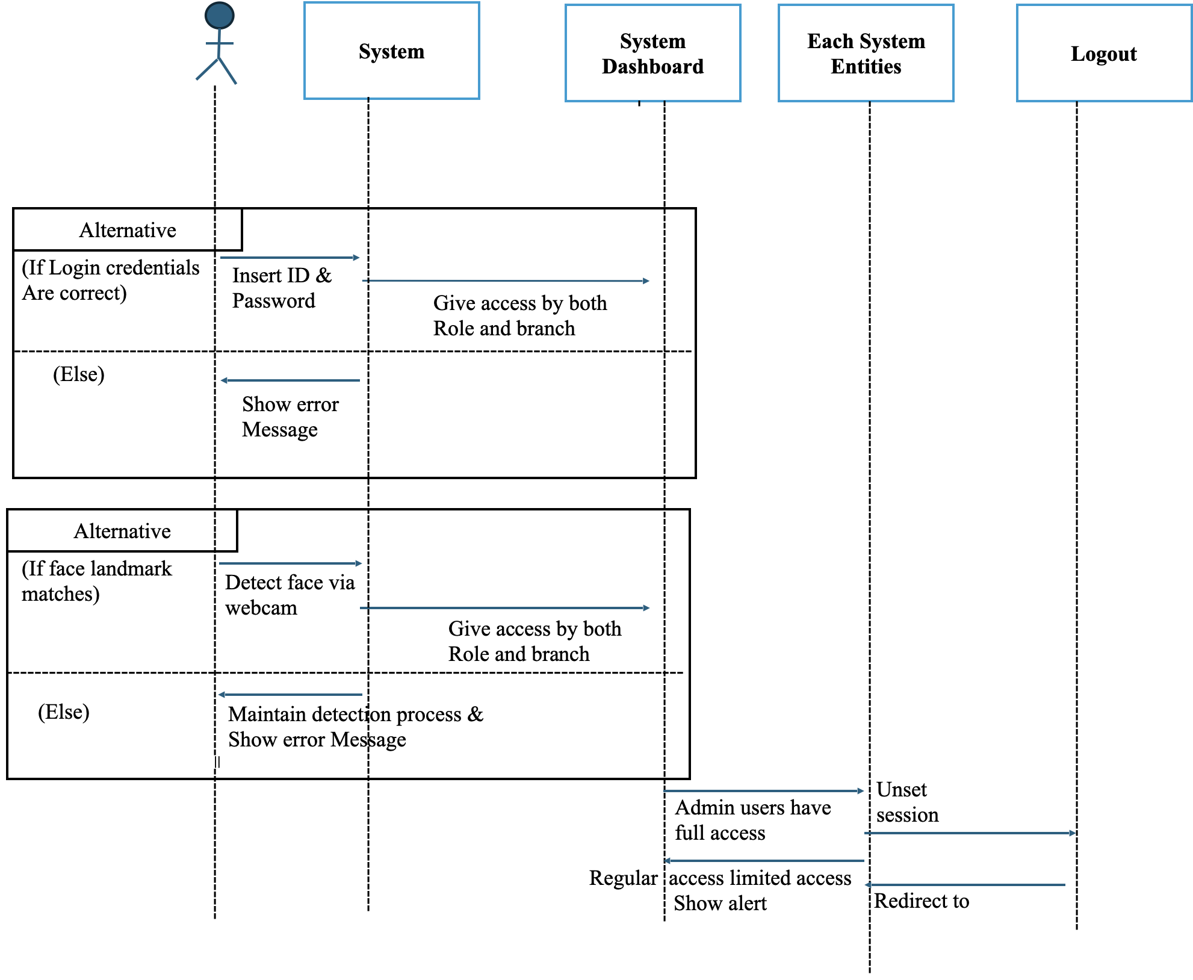

Fig. 1: Flow Diagram of Authentication using SFEAM
The flow diagram illustrated in Figure 1 graphically depicts the two independent authentication channels implemented in the proposed system: the conventional credential-based login and the relatively newer facial recognition-based authentication. Importantly, both paths map onto a common role-based access control paradigm to ensure that all successfully authenticated subjects, be they administrators with full system privileges or normal users with limited access, are given proper system access based on their authenticated digital identity.

2. The Proposed Methodology for Face Authentication

This section elaborates on the comprehensive architecture and core technological components of the Secured Face Encryption and Authentication Model (SFEAM). We delve into the intricacies of our approach, beginning with the client-side facial authentication mechanisms that prioritize user privacy and efficient processing. Subsequently, we detail the robust backend infrastructure designed for security, scalability, and high availability, leveraging cloud services. Furthermore, crucial aspects such as caching strategies and model optimization techniques, which are vital for ensuring responsive performance across diverse network conditions and devices, are discussed. The section also covers an analysis of the system's network performance and a thorough examination of its security posture, underscoring our commitment to developing a reliable and trustworthy authentication solution. Each subsection will break down these elements, providing a clear understanding of SFEAM's design and operational capabilities.

2.1 Face Authentication Technology and Implementation

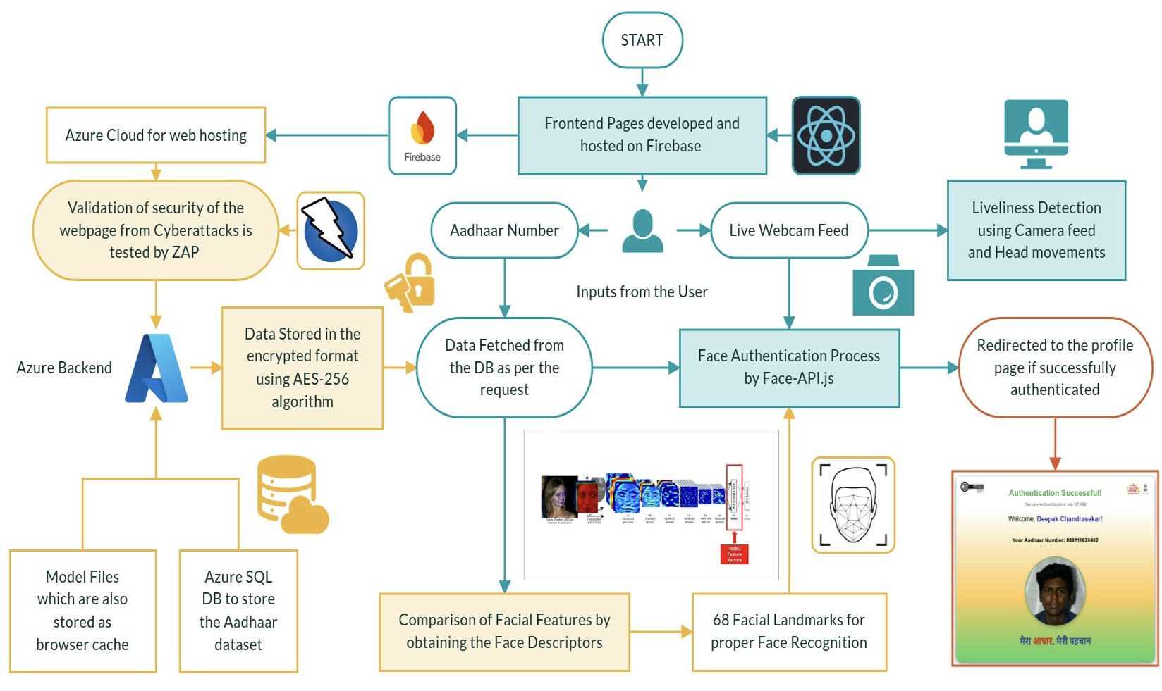
Fig. 2: System Architecture for working of SFEAM
Fig. 2 illustrates the system architecture of the proposed facial authentication framework that integrates Aadhaar verification with advanced security features. The system’s frontend pages are hosted on Firebase, where users can provide their Aadhaar number and their webcam’s live feed. The webcam’s output undergoes liveness detection which prevents spoofing attacks by analyzing the output and head movements. At the same time, the user's Aadhaar data is fetched from the database. The Face Authentication involves generating face descriptors from the live webcam feed and data security is ensured through AES-256 [9] encryption in Azure SQL database, with additional validation against cyberattacks performed using ZAP. Upon successful authentication, users are redirected to their profile page. Azure Cloud is used for web hosting and model files are stored in browser cache to obtain optimal performance.

Face-api.js Framework: SFEAM leverages face-api.js as the core of its client-side authentication capabilities, utilizing the robust JavaScript library, which is built on TensorFlow.js, to perform complex facial recognition operations entirely within the user's browser. This open-source framework enables SFEAM to implement a sophisticated multi-stage pipeline for both accuracy and efficiency. For initial face detection, SFEAM employs the library's implementation of the SSD MobileNetV1 architecture, chosen for its efficiency and ability to deliver real-time performance even on low-end hardware [10, 11, 12]. Following successful detection, SFEAM utilizes face-api.js to identify 68 precise facial landmarks. This allows the system to accurately align the face, compensating for variations in head pose or orientation. Once aligned, SFEAM calls upon the framework's feature extraction capabilities to generate compact 128-dimensional facial descriptors. These descriptors serve as a mathematical representation of the user's unique facial characteristics, allowing for effective comparison without storing or transmitting the actual image. This client-side approach, powered by face-api.js, is fundamental to SFEAM's privacy-preserving design, ensuring that sensitive biometric data never leaves the user's device during the authentication process. The final authentication decision is made by calculating the Euclidean distance between the newly generated descriptor and the stored template, using carefully calibrated thresholds to balance security with usability [13, 14].

Anti-Spoofing Implementation: SFEAM has advanced anti-spoofing mechanisms to protect itself from fraudsters trying to trick the system. The proposed solution incorporates motion-based analysis to find the micro movements of faces that are found in live faces but not in still photographs. Blink detection is an additional authentication factor, which verifies that the input face has human-like features like blinking. Texture analysis algorithm is used to analyze skin patterns in different frequencies to distinguish a real face surface from a fake image. These security features work together without needing special hardware, making SFEAM both secure and accessible on regular devices. The anti-spoofing module keeps improving with thes machine learning techniques that adapt to emerging threat vectors [15, 16].
2.2 Backend Architecture and Security
SFEAM implements robust security protocols for overall system integrity, model management, and data protection, leveraging Azure cloud services for scalability and resilience. User data and facial descriptors utilize Azure's comprehensive encryption framework for protection both at-rest in Azure SQL Database and in-transit via mandatory HTTPS (TLS 1.3) communication [17]. The database architecture is optimized for descriptor retrieval and comparison while adhering to strict security standards.
A key aspect is the secure handling of the facial recognition models themselves. While models are encrypted using AES-256-CBC during persistent storage on the backend [9], a dedicated 'Model Preparation Service', running as an Azure Function or microservice, handles security for client distribution. During the model release cycle (a one-time process per model version), this service retrieves the finalized, optimized model (post-quantization and pruning). It then encrypts the model files using AES-256-CBC with a unique, version-specific symmetric key securely generated and managed within Azure Key Vault. The resulting encrypted model binary large object (blob) is stored in Azure Blob Storage, configured for CDN distribution to ensure low-latency access globally. This backend preparation ensures that models are cryptographically sealed before distribution. While the current implementation uses this one-time preparation, the architecture supports future extension to a just-in-time (JIT) model encryption strategy if needed.
This secure delivery mechanism extends to the client. The download of the prepared, AES-encrypted model blob via HTTPS constitutes the secure binary code delivery. On the client-side, this encrypted blob is cached persistently using IndexedDB, managed via a Service Worker. Crucially, to prevent tampering or reverse engineering within the browser, decryption occurs only in memory immediately prior to loading into the TensorFlow.js runtime. This uses the browser's native Web Crypto API, and the required decryption key is fetched securely from a backend endpoint during the user's authenticated session. The raw, decrypted model weights are never written to persistent browser storage. Furthermore, the JavaScript code responsible for key fetching, decryption, and model loading is subjected to multi-layered obfuscation techniques (e.g., variable renaming, control flow flattening) to deter analysis. This layered approach ensures the model remains protected at the edge. Potential future enhancements include compiling parts of this client-side security logic into WebAssembly (WASM) for performance and added obfuscation.
Complementing model security, the architecture incorporates Azure Key Vault for managing all encryption keys, geo-replication for high availability, and Azure Firewall along with DDoS protection for network security [1, 15, 18]. Additional safeguards include SQL injection prevention through parameterized queries, CORS policies restricting unauthorized domain access, and role-based access control via Azure Active Directory [10], limiting access to authorized personnel and preventing misuse.
For high-volume operations anticipated in population-scale solutions, SFEAM employs multithreading where applicable and relies on Azure Load Balancer with auto-scaling capabilities to optimize resource allocation. Azure Traffic Manager intelligently routes geographically distributed requests, minimizing response times [19, 20, 21]. This infrastructure ensures authentication services remain responsive under varying loads and user locations.

2.3 Caching Mechanism and Model Optimization
Efficient caching and model optimization are vital for SFEAM's performance and user experience, especially across diverse network conditions and device [20].
SFEAM employs a multi-layered caching strategy. HTTP headers enable intelligent browser caching of static assets, including the initial application code. For the ML models and related datasets, Service Workers are used to cache these resources persistently after the initial download [11]. This allows for offline access capabilities and significantly faster subsequent authentications, as the model can be loaded directly from the local cache. For managing the cached model data (specifically the encrypted model blob discussed in Section 3.2), SFEAM leverages IndexedDB, accessed via the idblibrary for simplified interaction. The system enforces a cache memory cap (e.g., 7MB per model component) to prevent excessive disk usage, intelligently retrieving cached data on page refresh and automatically clearing older or excess data.
Model Size Optimization: Achieving efficient delivery, particularly over constrained networks (3G/4G), necessitates minimizing model size without sacrificing accuracy. While industry practices sometimes involve formats such as Flatbuffers, the current SFEAM implementation utilizes the standard TensorFlow.js Layers format (typically model.json plus binary weight shards) for SFEAMless integration with face-api.js and the TensorFlow.js ecosystem. To reduce the size of this model, SFEAM employs advanced quantization techniques, converting high-precision floating-point weights to lower-bit representations (e.g., 16-bit or 8-bit integers) [11]. This dramatically decreases memory footprint and download size. Careful implementation balances precision reduction against recognition accuracy. Complementing quantization, network pruning systematically identifies and removes redundant connections or weights within the neural network that contribute minimally to performance, further reducing size. These combined techniques successfully reduce the operational model size to under the target 7 MB threshold while maintaining high detection accuracy (above 98.5% in tests).
Performance Benefits: The integrated caching and optimization strategies yield substantial improvements. Load time measurements show significant reductions for returning users compared to first-time visitors (e.g., up to 85% faster authentication process completion on 4G after initial caching) [19]. Bandwidth consumption drops drastically after the initial model download (e.g., from ~6.8 MB to ~0.2 MB), making SFEAM viable in low-bandwidth environments [22]. These optimizations are key to enabling functionality on resource-constrained devices.

2.4 Network Performance Analysis
Performance over heterogeneous networks The establishment of a nationwide user authentication service mandates a solid performance over different types of network. In this section, we evaluate performance of SFEAM in different network environments and the processing strategies adapted to make sure that equal authenticating experience can be experienced across the country. Network Throttling and Lighthouse performance audit integration is provided by Chrome DevTools to emulate 3G, 4G, or 5G connection types. The assessment framework consisted of standard Web Vitals metrics as well as measurements that are specific for an authentication scenario: model loading time, face detection initialization and authentication completion time. Experiments have been performed in various device types to reflect the diversity of the end-user's device environment. The observed results revealed significant performance variations across network environments. In 5G conditions, SFEAM demonstrated exceptional performance with authentication completion times consistently below 2 seconds. Model loading and face detection initialization happened almost instantly, showing that in high-speed internet environments, the device's processing power limits performance more than network speed. With 4G connections, the system worked well with average login times of 3.2 seconds, though downloading the initial data took 2.4 seconds. This indicates that transferring files represents the main slowdown with moderate internet speeds. The 3G results were more problematic, with login completion taking 7.8 seconds and initial data loading requiring 5.2 seconds. The system still worked, but these delays were longer than ideal and might discourage users in areas with poor internet connectivity.

2.5 Security Analysis
Security testing of the SFEAM authentication system shows it provides strong protection suitable for large-scale government use. The evaluation followed established security standards from OWASP, NIST, and UIDAI guidelines, using automated scans, manual code inspection, and thorough data pathway examination. The SFEAM system incorporates several effective protective measures that safeguard sensitive information. Processing biometric data on users' devices means original face images stay local, greatly limiting exposure to data breaches. Sensitive data receives protection through proven encryption methods: AES-256-CBC secures stored models, TLS 1.3 protects network traffic, and Azure SQL Database encrypts stored information.
The system design shows notable security advantages. Azure Key Vault handles encryption key management, while layered defenses protect networks, applications, and databases simultaneously. This comprehensive approach addresses potential weaknesses across different system components. Security testing revealed one moderate concern: insufficient cache management that might expose data on shared computers. Though this issue needs correction, it doesn't undermine the system's overall security strength. Minor implementation details were noted but present little actual risk. Laboratory tests confirmed that SFEAM's anti-spoofing protections work effectively against attempted attacks.

3. Experimental Results:
The SFEAM system underwent comprehensive testing to evaluate its performance across key dimensions, including recognition accuracy, anti-spoofing effectiveness, network responsiveness, and resource utilization. These dimensions were chosen to ensure a robust and equitable assessment of its capabilities for real-world deployment. Before detailing SFEAM's specific performance metrics, it is important to understand its distinct design philosophy and operational context relative to foundational facial recognition research models such as FaceNet, DeepFace, SphereFace, and ArcFace. Table 1 provides a comparative overview of these differences, highlighting SFEAM's focus on client-side execution, integrated anti-spoofing, model efficiency for web deployment, and its overarching goal as a deployable authentication system. This context is essential for interpreting the experimental results that follow.

Table 1: Comparative Analysis of SFEAM System versus Traditional Facial Recognition Models
Feature | SFEAM | FaceNet / DeepFace / SphereFace / ArcFace (General Characteristics as Research Models)
Architectural Design for Execution | Designed for client-side execution in web browsers (via TensorFlow.js, face-api.js) to enhance privacy and reduce server load. | Primarily developed and benchmarked in server-side environments; client-side deployment requires significant adaptation, optimization, and is not the initial focus.
Anti-Spoofing Integration | Integrates multi-modal anti-spoofing (motion, blink, texture) as a core system component designed for robust real-world deployment. | Core research typically focuses on recognition accuracy; anti-spoofing is often addressed as a separate research module or subsequent problem, not intrinsically built into the foundational models.
Model Optimization & Size Priority | Prioritizes high model efficiency (<7MB via post-training quantization & pruning) specifically for fast web delivery and performance on resource-constrained user devices. | Initial research prioritizes maximizing recognition accuracy, often leading to larger, more complex models; optimization for size and speed is a secondary step if targeted for specific deployments.
Primary Development Goal & Context | To develop a deployable, end-to-end secure authentication system (e.g., for Aadhaar) with emphasis on user experience, privacy, and practical security in a web environment. | To advance fundamental facial recognition algorithms, explore novel loss functions, and achieve/surpass state-of-the-art accuracy on academic benchmarks (e.g., LFW, MegaFace).
Data Privacy Assurance in Operation | Enhances data privacy by processing all facial recognition tasks locally within the browser, preventing raw biometric data transmission during the authentication phase. | Typically require biometric data (image or features) to be sent to a server for processing. Data privacy then becomes contingent on the security measures and policies implemented on the server side.

The core facial recognition component was benchmarked against a controlled dataset comprising 5,000 face images representing diverse demographic groups. The system achieved a high overall recognition accuracy of 99.4%. The false acceptance rate (FAR) was measured at a low 0.02%, while the false rejection rate (FRR) was 0.8%. These metrics demonstrate performance comparable to state-of-the-art facial recognition systems, achieved while maintaining the privacy advantages inherent in SFEAM's client-side processing architecture. Security against presentation attacks was a key evaluation criterion. The integrated anti-spoofing mechanisms, relying on techniques such as liveness detection through motion and blink analysis, demonstrated strong capabilities. The system achieved 94.3% effectiveness against Level 1 presentation attacks, which include common spoofing attempts using printed photographs and basic video replays, confirming its readiness for practical deployment scenarios.
System responsiveness was rigorously evaluated across simulated 5G, 4G, and 3G network conditions using Chrome DevTools Network Throttling and Lighthouse performance audits. Table 2 summarizes key performance scores and standard Web Vitals metrics under these varied conditions.
Table. 2: Comparative Analysis of Network Performance Metrics Across 5G, 4G, and 3G
Metric | 5G Network | 4G Network | 3G Network
Performance Score (points) | 100 | 69 | 69
Accessibility Score (points) | 91 | 90 | 87
Best Practices Score (points) | 100 | 83 | 85
SEO Score (points) | 82 | 100 | 100
First Contentful Paint (seconds) | 0.5 | 0.6 | 0.6
Largest Contentful Paint (seconds) | 0.5 | 0.6 | 0.7
Total Blocking Time (milliseconds) | 10 | 6.75 | 6.75

Beyond the Lighthouse scores, specific timing measurements revealed the practical impact of network bandwidth. Under optimal 5G conditions, the end-to-end authentication process completed in under 2 seconds. In 4G environments, the mean authentication time increased to 3.2 seconds, with initial model loading accounting for 2.4 seconds. Performance was functional but significantly slower in simulated 3G conditions, where authentication took an average of 7.8 seconds and model loading required 5.2 seconds. While initial summaries reported high overall performance scores ('perfect' on 5G, 87/100 on 4G/3G), Table 2 provides the detailed breakdown from Lighthouse audits.
The implemented multi-layered caching strategy (including browser HTTP caching, service workers, and IndexedDB) yielded substantial performance improvements, particularly for returning users. Compared to first-time visitors (who experienced model loading times of approximately 2.4s and total authentication times of 3.2s on a 4G network), returning users benefited from dramatically reduced times: model loading decreased to 0.3s (an 87.5% improvement), and the complete authentication process took only 1.1s (a 65.6% improvement). Consequently, data transfer requirements plummeted from 6.8 MB on initial visits to just 0.2 MB for subsequent authentications, validating the caching approach's effectiveness, especially in bandwidth-constrained environments [23].
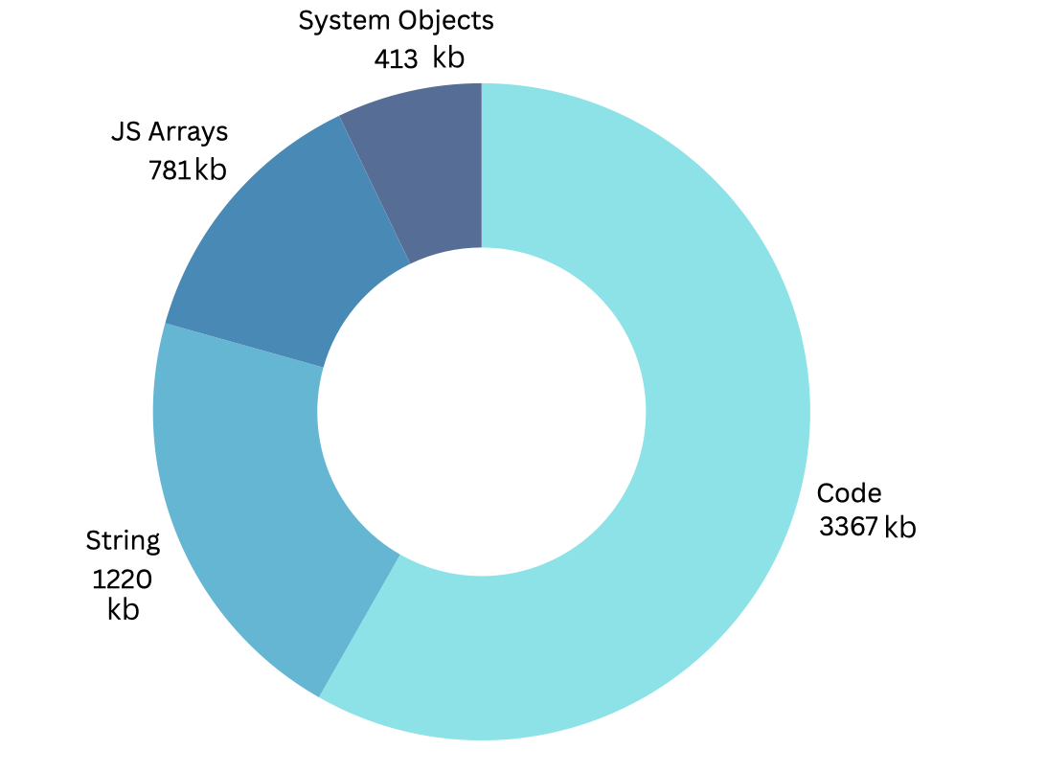
Fig. 3: Composition of Client-Side Memory Footprint After Model Optimization
Model optimization techniques, specifically quantization and pruning, were crucial for efficiency. These methods achieved a 43% reduction in the facial recognition model's size, successfully keeping the overall client application footprint under the target 7 MB threshold. Figure 3 illustrates the resulting memory composition of the primary client-side components after these optimizations. Importantly, this optimization was performed while maintaining detection accuracy above 98.5%. The reduced model size directly contributed to faster loading times across all networks, with the most significant impact in 3G environments (a 40.2% reduction in loading time). The combination of optimization and caching also improved authentication initialization speed by up to 89% for returning users across various network conditions.
Regarding computational efficiency on the client device, the core face detection and feature comparison operations consistently executed in under one second during testing. This rapid performance is facilitated by the underlying face-api.js library (built on TensorFlow.js), which is optimized for browser environments and can leverage modern hardware capabilities, potentially including multicore CPU processing or GPU acceleration where available, for efficient execution.

4. Conclusion & Future Reference
SFEAM addresses effectively the complex issues of deploying secure, efficient, and accessible facial authentication for national identity verification systems. With its focus on client-side processing, SFEAM efficiently traverses the sensitive balance between security and privacy to provide a system that can function adequately under varied network and device environments. The establishment of a privacy-protecting authentication system that limits processing of biometric data to the device belonging to the user is a major step in biometric security procedures. The incorporation of strong anti-spoofing mechanisms has proved effective against standard presentation attacks, whereas our complete optimization methods guarantee some level of functionality in a wide range of network conditions and device capabilities. This project highlights the potential of web-based technologies to provide advanced biometric authentication schemes at a price point that doesn't compromise security while also avoiding specialized hardware. From our performance evaluations across varying network conditions, it becomes clear that while SFEAM works adequately under most situations, further enhancements must be made in order to ensure fair access where there are inadequate network links. The security architecture that supports SFEAM provides strong protection for sensitive biometric and identity information, closely matching the high standards required of a national digital identity infrastructure.

In the future, our ongoing work will focus on a number of key areas for improvement. We will work to enhance anti-spoofing capabilities to enhance detection rates against more advanced presentation attacks, such as deepfakes and high-fidelity 3D masks. Addressing the inherent challenges in differentiating between identical twins remains a complex but crucial area for future investigation. The implementation of regional edge caching, strategically positioned at distribution points, will be explored to reduce latency in remote areas with constrained network infrastructure. We also plan to develop secure offline authentication options to maintain security while minimizing dependence on real-time network connectivity. In addition, the incorporation of explainable AI (XAI) elements will be sought in order to create transparency into the authentication decisioning process, to meet changing regulatory requirements for algorithmic accountability in identity systems.

